What about DAT

**Design Art Technology, your study program?**

**Design Art Technology is a study program that operates at the intersection of design, art and technology.**

**Our world is increasingly characterised by digital technology: from physical devices such as computers, smartphones, screens and robots to invisible systems that enable our communication such as the internet, data, software, algorithms and artificial intelligence. This technology has a profound impact on our society and our lives. Social media are changing how we represent ourselves and communicate with others. Algorithms influence which information we can and cannot see. Displays and smart technology are changing our behaviour and our environment. Robots and artificial intelligence are even changing what it means to be human.**

At Design Art Technology students are challenged to reflect on these changes. They learn to shape our technological world in an innovative and artistic way, and use technology for their own artistic expression. By experimenting with new techniques, investigating how our perception changes, and exploring the problems and possibilities of our digital culture, they respond to current questions from society. The program invites students to ask critical questions – sometimes questions that have not been asked before – and to make people think through their work. As a result, they actively contribute to new creative visions of the future.

Design Art Technology trains a wide spectrum of makers; from designers to autonomous artists. The program focusses on learning to deal with the complexity of our media-technological landscape – in a technical, aesthetic, sociocultural and political sense. As designers and artists, the students of Design Art Technology know how to convert this complexity into critical reflections on, new imaginations of and alternative applications for technological media. They design interactive systems that can take many forms: from websites, videos, (data) visualisations, apps, games and wearables to virtual worlds, machines, instruments and interactive installations. Design Art Technology is therefore a unique study program that challenges its students to shape our new world.

**Student work**

Within the department, students develop their projects at the cross roads of Design Art and Technology. Below are some examples of student work. While some works more clearly fit one of the three fields, Design Art and Technology are in fact always part of every project.

**Design**

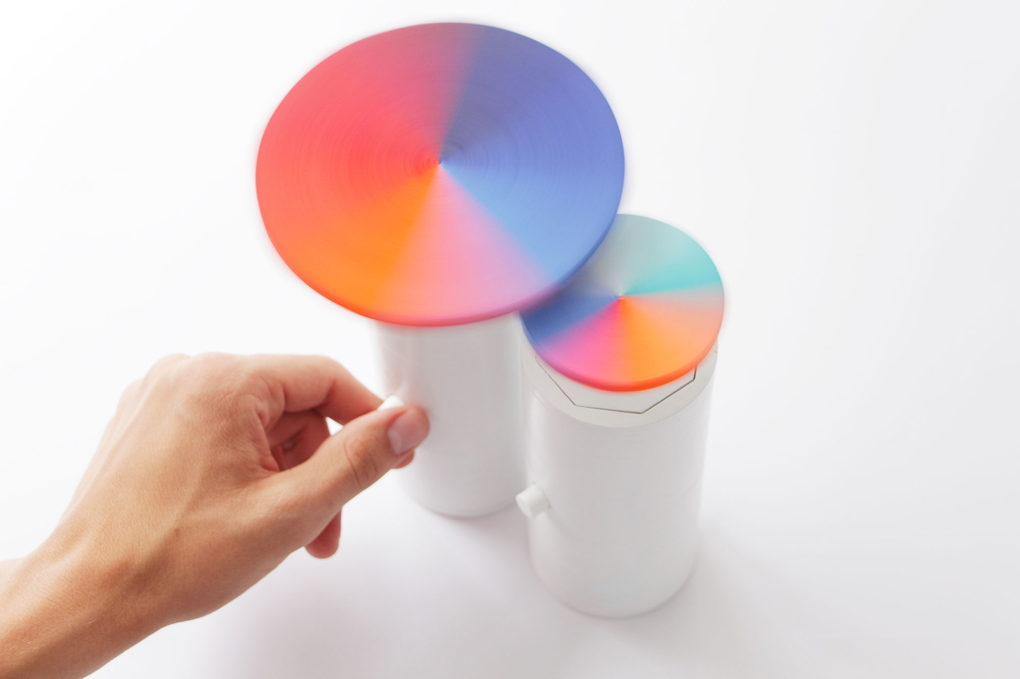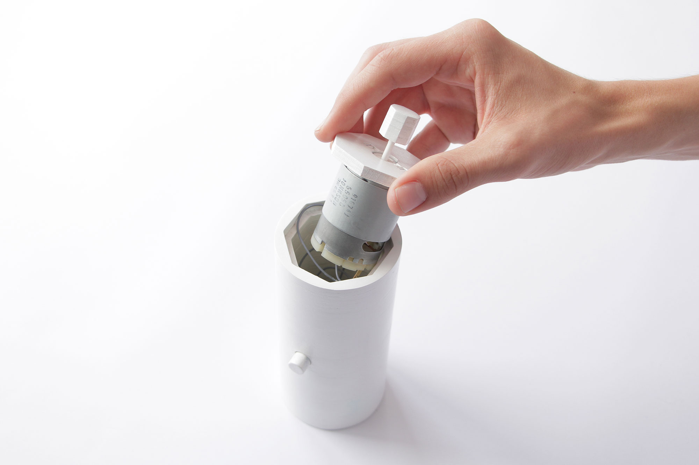**Michelle van Ool, *Optic Deception*, year?**

Although video footage seems identical to how we perceive the world with our eyes, there is a big difference between human and technological perception. As human beings we need only 13 milliseconds to perceive an image. Camera's, on the other hand, record with a frame rate of 25 frames per second. *Optic Deception* is a project that shows the differences in perception between our eyes and the camera. Michelle van Ool designed a series of colour wheels that are driven by motors spinning at a speed of 75 rotations per second. At this specific speed, our naked eyes are not able to perceive any of the colours. The colours appear only when the wheels are viewed through a camera.

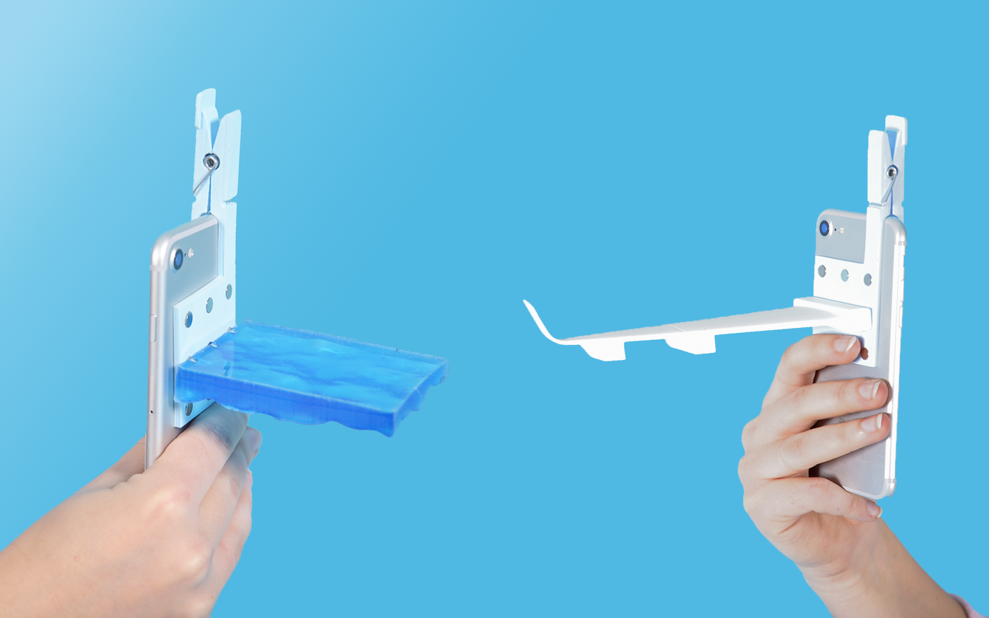

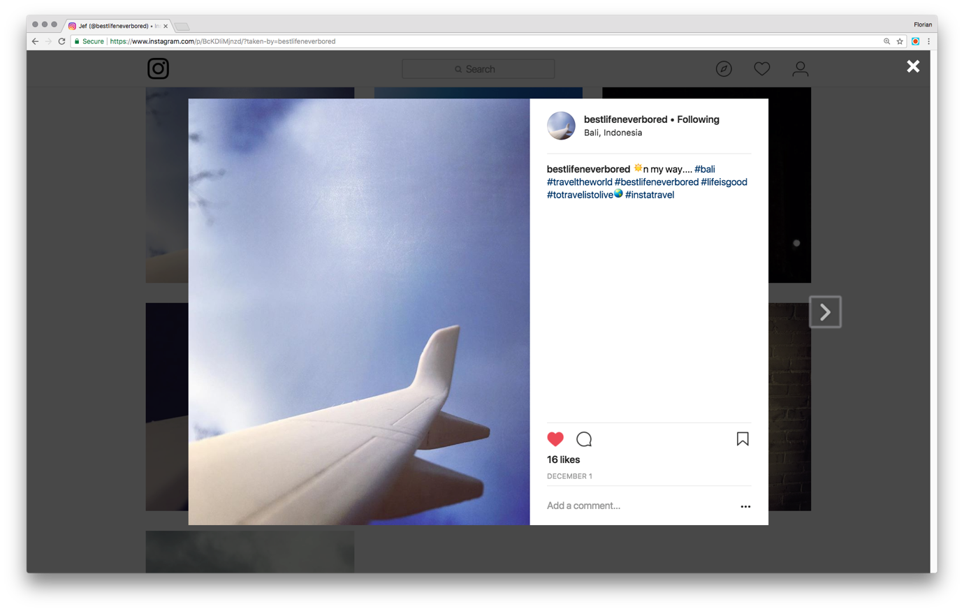

**Florian van Zandwijk, *PHONY Toolkit*, year?**

Social media urges us to constantly share how fantastic our lives are. Sharing stereotypical travel-images of far-away places has become an essential part of this. *PHONY Toolkit* is a smart phone clip-on that comes with an infinity pool and an airplane wing. With this toolkit Florian van Zandwijk allows you to escape the travel-pressure and fake perfect travel pictures without ever having to leave your home.

**Art**

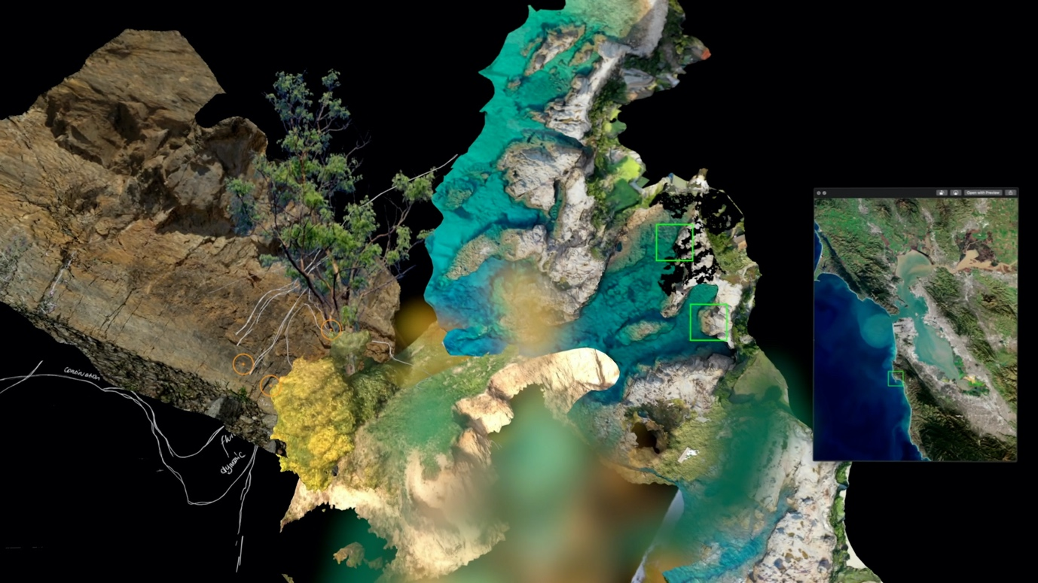

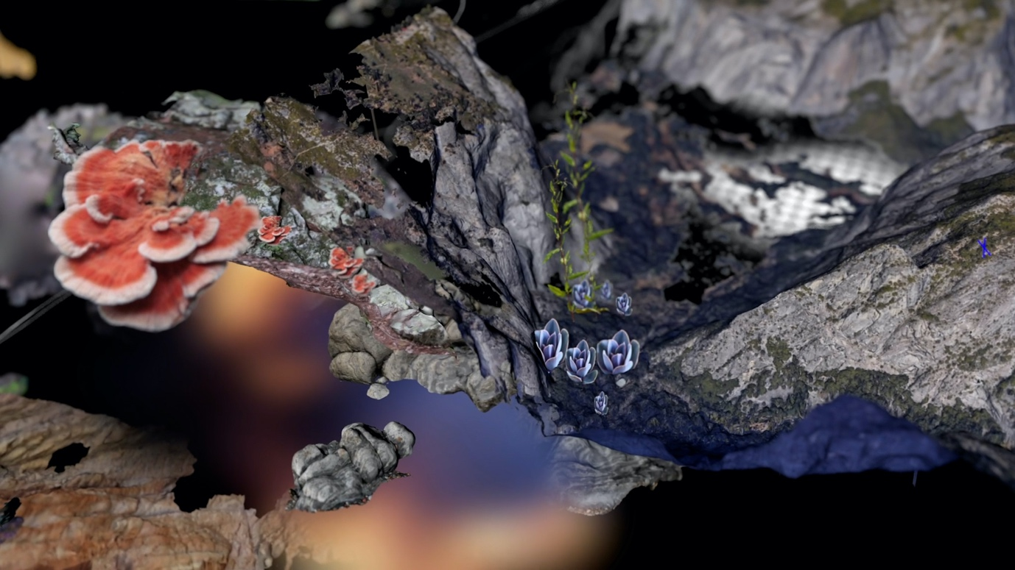

**Deborah Mora, *0°N 0°E*, 2020**

*0°N 0°E* is a video installation that visualises the cyber-myth of the Null island: a fictional island imagined to float at the intersection of the prime meridian and the equator, at the 0°, 0° coordinates position. Deborah Mora noticed that the null value is also attributed to images, files and recordings that are uploaded online without a specific geo-position. By downloading and combining photographs, satellite pictures, 3D models and sound recordings with the 0,0 location, *0°N 0°E* becomes an archive where all the lost objects come together in the form of a fictional island. Deborah created an immersive exploration of the visual and sonic landscape of this island, which evokes an otherworldly atmosphere where the natural and organic meet the electronic and artificial. In doing so, *0°N 0°E* offers an experience of nature that exists in – and can only be accessed through – digital mediation.

*This work was shown at Fiber Festival (2020) and featured on NextNature.net and NextMuseum.io.*

https://vimeo.com/480690166**---------------------------------**

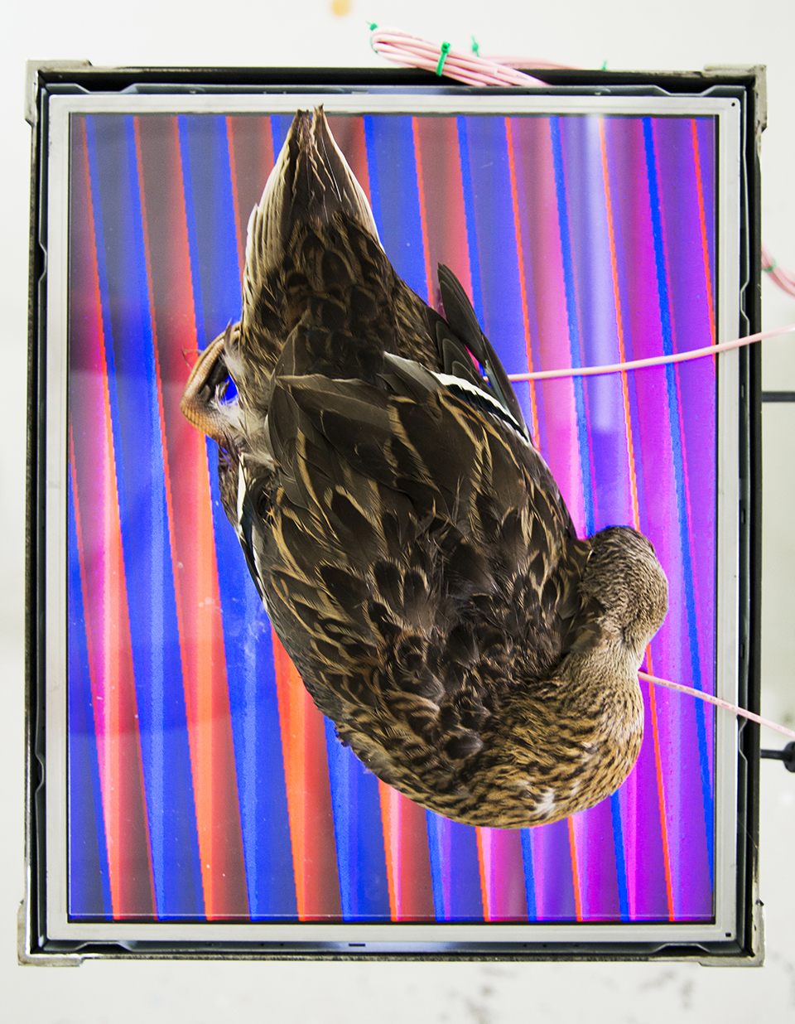

**Amy Whittle, *Artificial Afterlife*, 2016**

*Artificial Afterlife* by Amy Whittle is an installation that visualises the energy stored in the fluids of the dead. By connecting a dead animal (donated by a local animal rescue centre) to an electric circuit, Amy was able to transform the animal’s remaining energy into red and blue visuals on the screen. Inspired by the famous novel *Frankenstein* and scientific experiments from the 18th century (like Luigi Galvani who applied electric current to dissected frogs in order to animate their limbs) as well as by contemporary ideas like brain-uploading and developments in AI, *Artificial Afterlife* examines the possibility of technological life after death. ‘As a non-believer I too desire a form of afterlife,’ Amy writes, and ‘as an interaction designer I believe these notions can be realised with the help of technology.’ However, the installation is not a scientific project. Instead, it is an artwork that explores how the seemingly opposing fields of technology and spirituality can be connected, inviting us to reflect on the mystification of technology.

*This work was selected by Creative Applications as Highlight and Favourite (2016) and won the Hendrik Valk Award (2017).*

**Technology**

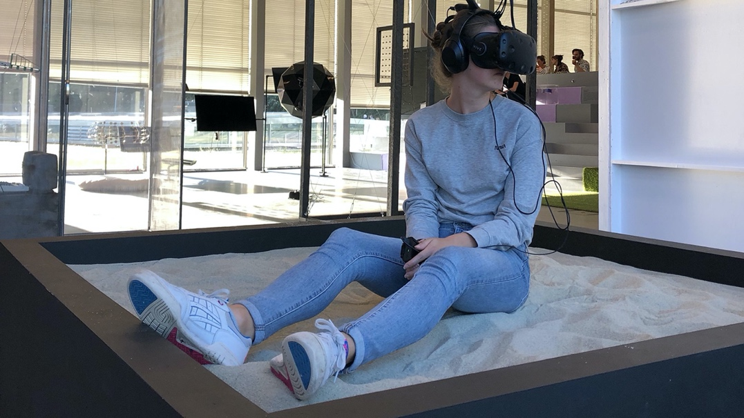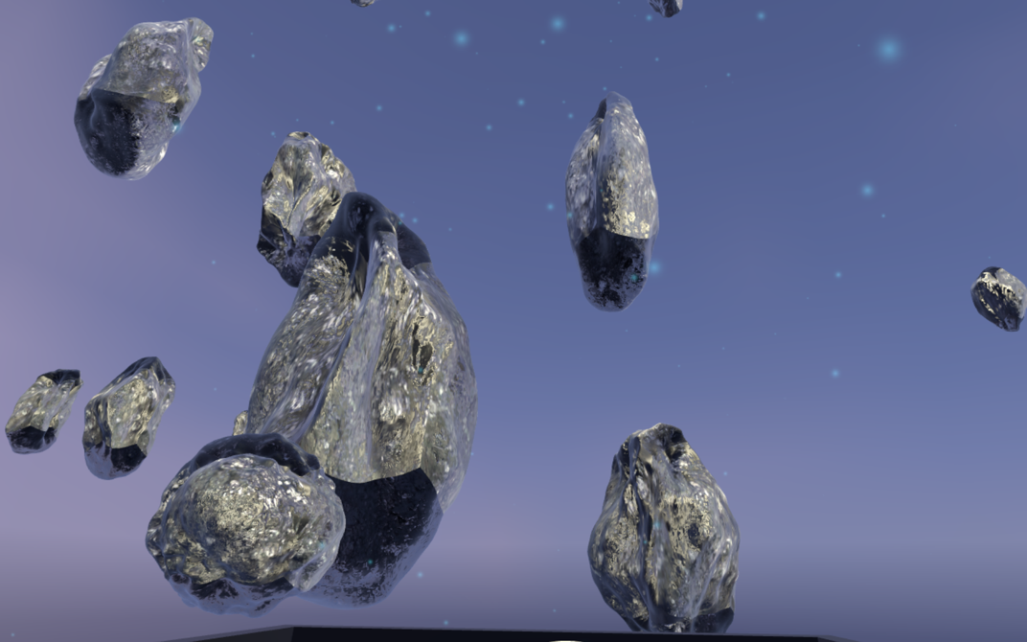

**Eva van Boxtel, *Manufacturing Chips*, 2019**

For Dutch technology-company NXP, Eva van Boxtel designed a virtual reality installation that immerses the viewer into the world of computer chip manufacturing. The viewer takes place on a platform filled with soft quartz sand – the base material of silicon and computer chips – puts on a VR headset and experiences the wonderous world of chip manufacturing. *Manufacturing Chips* consists of a series of mesmerizing 3D-animated worlds that show important steps in the production process (like slicing and engraving silicon) and highlights the aesthetic quality of the materials, shapes and techniques that are used. By slowing down and magnifying the high-speed microscopic process of manufacturing chips, Eva draws attention to the hidden beauty of our technological world.

*This work was shown at GOGBOT festival (2019) and received a Youngblood Award*

**---------------------------------**

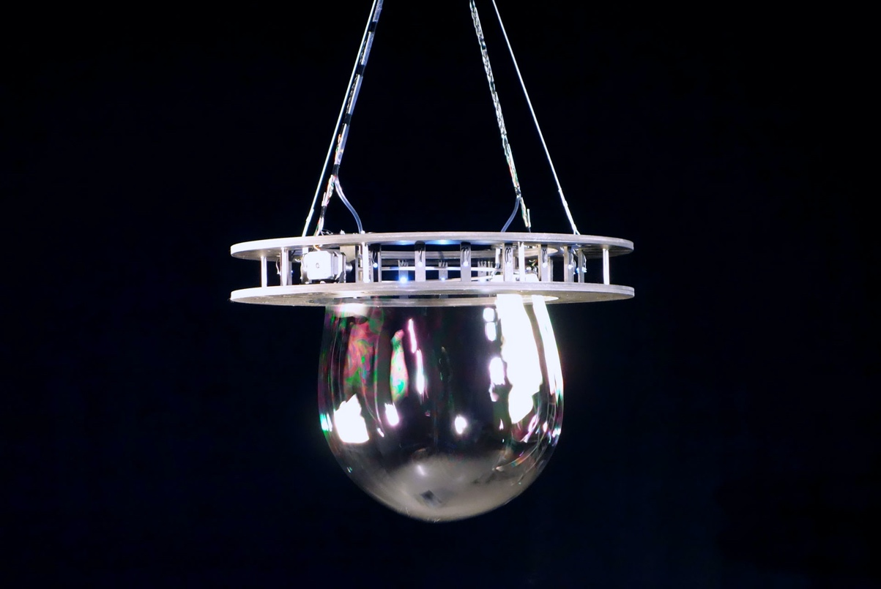

**Willem Kempers & Amy Whittle, *Lung*, year?**

*Lung* is a device that visualises breathing data using soap bubbles. Designers Willem Kempers and Amy Whittle wanted to understand their own breathing patterns better, because breathing patterns have influence on our stress and anxiety levels. Their idea was that if you’re able to control your breathing, this could have a great effect on your health. To achieve a better understanding of their breathing patterns, Willem and Amy first placed temperature sensors in their noses while doing different activities to record their respiration rates. Because the designers believe that some data is better understood through experience than infographics, they built *Lung*. The device consists of two rings that open and close in sync with the breathing rhythms they recorded. On each exhalation, *Lung* blows a soap bubble, turning something that normally goes unnoticed into a beautiful experience.

*This work was featured on CreativeApplications.net and FastCompany.com*

<https://vimeo.com/99224726>

**---------------------------------**

**Practical information**

Design Art Technology by the head of the department Martijn van Boven

<https://we.tl/t-DkiT2TWHuP>

**Admissions**

Applications for the academic year 2021-2022 are now open!

If you want to study at ArtEZ Design Art Technology, sign up for admissions.

Due to Covid19 regulations, application interviews for prospective students are offered online on the following dates:

1 March

12 April

3 May

7 June

If you want to book a portfolio session, mail our department coordinator Anke van Loon: a.vanloon@artez.nl